|  |
| --- |
| KTH - Royal Institute of Technology |
| RDUP |
| IK2213 Network Services and Internet-based Applications |

|  |
| --- |
| Sike Huang and Shanbo Li  2008-6-8 |

# The Idea

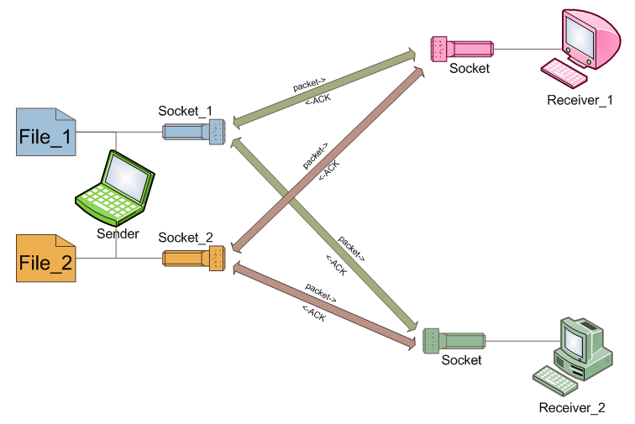

The sender can transfer multiple files to several receivers, as illustrated in the figure above, there are two files on the sender’s side, and each file binds to a socket. Since there two receivers, a file is sent via its associated socket to all the receivers respectively.

# The Data Structure

We define several data structures in ***rudp_api.h***

// define the states of a (file transfer) session

**typedef** **enum** **{**

RSESSION_START**,** // session has started

RSESSION_TRANSFER**,** // transfering

RSESSION_CLOSED**,** // session has been closed

WAIT_FOR_ACK_OF_FIN // waiting for last ACK (for FIN)

**}** enum_session**;**

// a datagram encapsulates the data to be sent/received

**struct** r_datagram **{**

**struct** rudp_hdr header**;** // type of data

**char** data**[**RUDP_MAXPKTSIZE**];** // data itself

**int** len**;** // length of data

**int** has_ack**;** // whether this data has been ACKed or not

**int** has_send**;** // whether this data has been sent or not

**int** retrans_num**;** // number of retransmission times

**struct** r_datagram**\*** next**;** // pointer to next datagram

**struct** sockaddr_in remote_addr**;** // remote socket

**struct** r_socket**\*** rsocket**;** // local socket

**struct** r_database**\*** database**;** // pointer to the database

**};**

// a database is used to maintain different sessions

**struct** r_database **{**

**struct** sockaddr_in **\***remote**;** // remote socket

**int** is_initialed**;** // -1 = false; 1 = true;

**int** last_recv_seq**;** // last recived sequence number

**int** last_send_seq**;** // last sent sequence number

enum_session session_state**;** // holds the state of session

**struct** r_datagram**\*** datagram_buffer**;** // holds datagrams

**struct** r_database**\*** next**;** // pointer to next database

**struct** r_database**\*** pre**;** // pointer to previous database

**};**

**typedef** **struct** r_database**\*** r_database_t**;**

// encapsulates a socket

**struct** r_socket **{**

**int** **(\***super_rudp_receiver**)(struct** r_socket**\*,** **struct** sockaddr_in**\*,** **char*,** **int);**

**int** **(\***super_event_handler**)(struct** r_socket**\*,** rudp_event_t**,** **struct** sockaddr_in **\*);**

**int** sd**;** // socket descriptor

// used by recevier to filter incoming file (identified by remote_socket and seq)

**struct** r_database**\*** database**;**

**};**

**typedef** **struct** r_socket**\*** rudp_socket_t**;**

# State Machine

## Sender

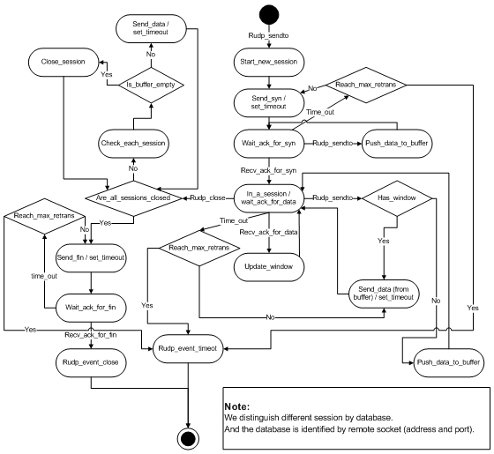

Figure Sender

Refer to **vs_send_statechart.png**

## Receiver

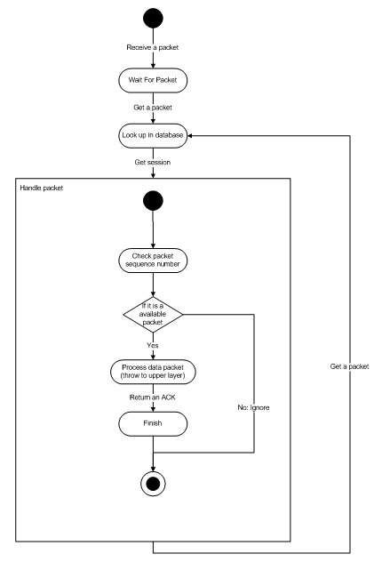

Figure Receiver

Refer to **vs_recv_statechart.png**